Waffles
Toasted Ravioli(6)(8)
Carrot Sticks(9)/Ranch
Mashed Potatoes
Apple Slices
Pineapple
Waffles
Wild Mike’s Pizza
Carrot Sticks(9)/Ranch
Mixed Vegetables
Apple Slices
Mandarin Oranges

NO SCHOOL
Pancakes
Chicken Sandwich
Broccoli/Ranch
Mixed Vegetables
Apple Slices
Pears

Tornado
Taco In A Bag
Salad with Tomatoes
Carrots
Orange Slices
Peaches

MANAGER’S CHOICE

Early Dismissal
No Lunch Served
Muffin
Spaghetti
Cheesy Bread(1/2)
Salad with Tomatoes
Green Beans
Orange Slices
Mango Peach Applesauce
Tornado
Corn Dog(1)(2)
Salad With Cucumbers
Green Beans
Orange Slices
Applesauce

Muffin
Chicken Nuggets(5)(7)
Salad With Cucumbers
Green Beans
Orange Slices
Mixed Fruit
Chocolate Chip Cookie
Pancake On A Stick
Chicken Nuggets(5)(7)
Marinated Vegetable Salad
Corn
Grapes
Applesauce
Oatmeal Cookie

English Muffin Sandwich
Chicken Strips(3)(4)
Creamy Cole Slaw
Sweet Potato Fries
Grapes
Mixed Fruit
Sugar Cookie

Mixed Fruit
Breakfast Bagel
Hamburger On A Bun
Marinated Vegetable Salad
Baked Beans
Grapes
Pears
Dino Bites

MANAGER’S CHOICE
Yogurt
BBQ Chicken Wings(4)(6)
Salad With Tomatoes
Carrots
Banana
Mango Peach Applesauce
French Toast Sticks
Bosco Sticks(1)(2)
Salad With Cucumbers
Carrots
Strawberries
Pineapple
Yogurt
Wild Mike’s Pizza
Mixed Greens Salad
Green Beans
Banana
Mandarin Oranges

MANAGER’S CHOICE
Pancake On A Stick
Tator Tot Casserole
Carrot Sticks(9)/Ranch
Baked Beans
Applesauce
Peaches

MANAGER’S CHOICE

French Toast Sticks
Chicken Strips(3)(4)
Broccoli/Ranch
Mashed Potatoes
Strawberries
Mixed Fruit

English Muffin Sandwich
Sloppy Joe
Broccoli/Ranch
Sweet Potato Fries
Grapes
Mango Peach Applesauce

NO SCHOOL

NO SCHOOL
Auburn K-8 Menu

Breakfast items available on a daily basis include cold cereal, milk, toast, fruit, and juice.
Milk is available daily at lunch.
Student Breakfast $2.00
Adult Breakfast $2.50
Student Lunch $3.00
Adult Lunch $3.65
Extra Entrée $1.40
Extra Milk $0.50
Small Juice $0.50
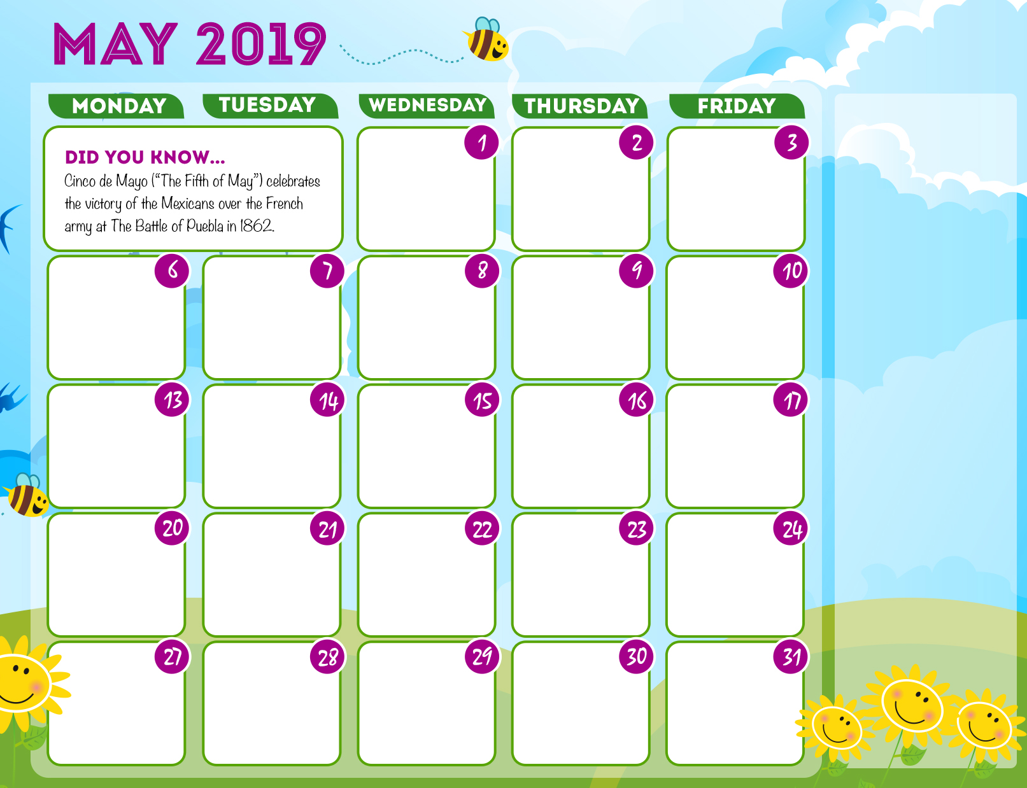
Sometimes You Face Difficulties Not Because You’re Doing Something Wrong, But Because You Are Doing Something Right.

